MY COUNTRY, 1-2-3

NUMBER ONE: IT’S JULY 4TH IN MY COUNTRY

I am an American citizen. When I look at our neighborhood’s July 4th parade, I see the cute kids riding their flag- and streamer-bedecked bikes and trikes, riding down the street as the elderly folk in their chairs, curbside, cheer them on; the potluck and barbeque meal we all share down on the corner, etc. Smiles and greetings -- all very pleasant.

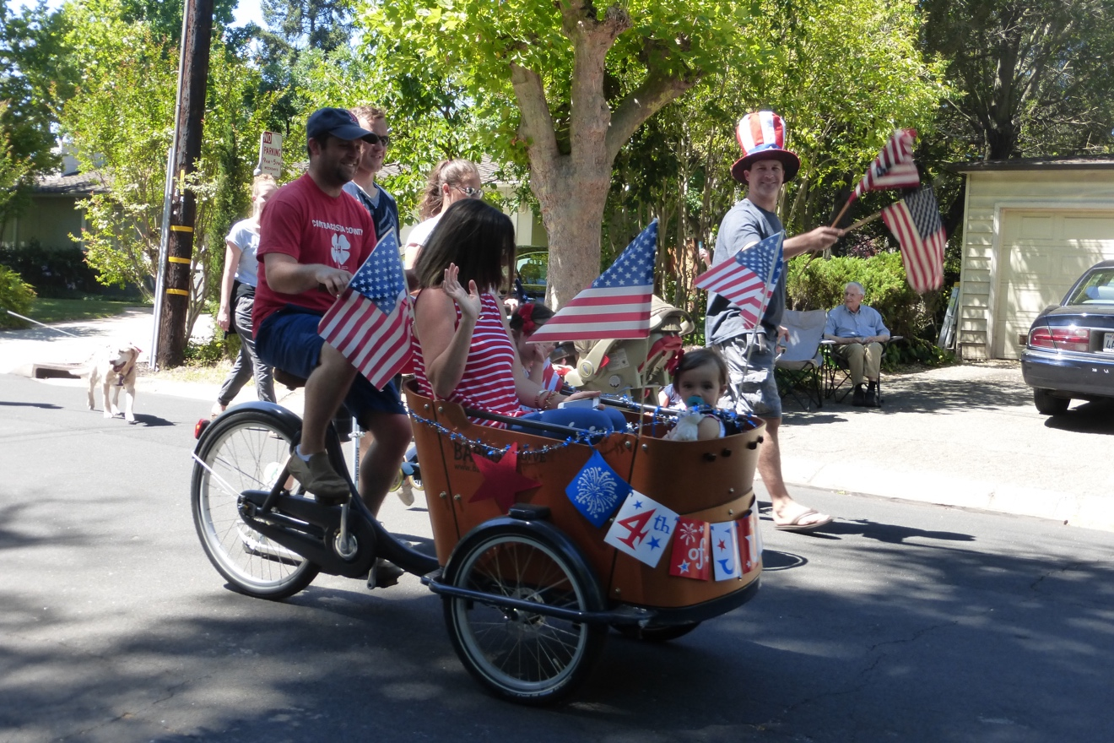

What makes this scene remarkable is how rare this display of community now is in a society so jaded by corny patriotism and divided by often vehement controversy. We are conscious of how old-fashioned this is, and we choose to do it despite our disagreements.

Without a doubt, this event raises all kinds of local-global questions -- not the least of which is, why does my friend Tony parade down the street carrying an American flag while dressed in the British Union Jack, representing his country of birth. After all, Britain is – yes, our ally, today – but also the very country against which we Americans fought this Revolution that we now celebrate!

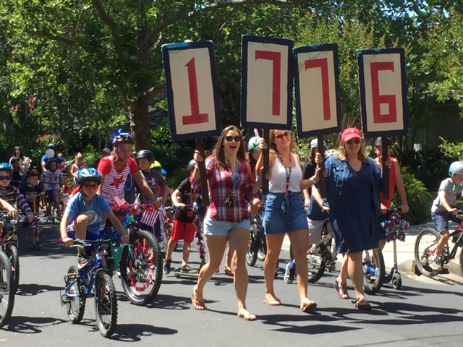

And why do I say, ‘we Americans fought,’ when it wasn’t me, and in any case, my ancestors arrived a full century after that conflict. In fact, our neighborhood July 4th celebration is filled with people who have moved here from around the world in their own lifetimes -- I am sure the foreign-born locals vastly outnumber the descendants of the Mayflower or the American Revolution. This in itself is worth celebrating.

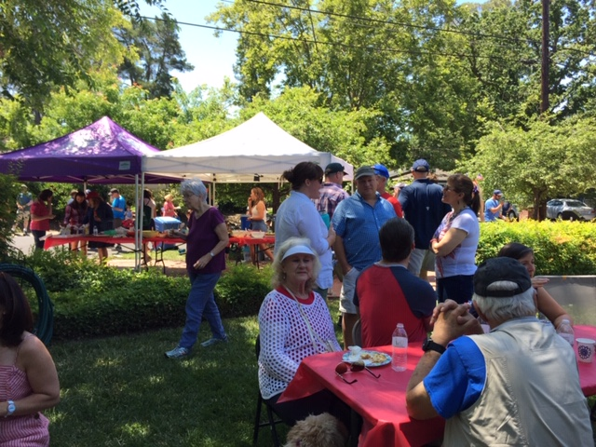

But as my neighbors and I celebrate, what can we say about the wholeness of American neighborhoods in general? Here, I walk down the street almost every day and greet the neighbors, some of whom -- but hardly all of whom -- do the same thing. When we gather for this holiday or for Halloween (which draws hundreds from beyond our neighborhood to our streets), we see old and young, gay and straight, small and large families, single moms and single dads, all friendly and polite, glad to share this time . . . but ready to return home and to other people and activities. Some of us are best friends with each other, and some are merely courteous. Some of us meet for coffee, wine, or beer or parties frequently, and some are almost complete strangers to me.

When I’ve described this neighborhood and event to people elsewhere, some say that their town is similar, but many others have been impressed by my fortunate community’s apparent cohesion and bemoan the fact that they don’t know their neighbors at all. Unfortunately, some Americans experience alienation and even fear of neighbors; many neighborhoods are dysfunctional. If you live in a crime-ridden area, trust is in short supply. This is true around the world, but it is also true even in many relatively safe parts of the U.S., where individualism is so strong, classes so divided, political antagonism so rife, and geographic mobility so common, that many of us don’t know our neighbors at all.

In fact, according to the US General Social Survey two years ago, 34% of Americans never socialize with their neighbors -- and that percentage is growing. One third of Americans -- this is not necessarily the same group -- also live alone; some of them are doing well, but others must be very lonely.

My neighbors and I are part of the remaining 66% who do socialize with each other, even if superficially. But the truth is, we struggle to maintain community. Maybe we even gather out of a nostalgic sense of neighborhood we believe should be the case. We want this, so we work at it. Living near someone does not mean being close to them -- we may be emotionally much closer to someone 5000 miles away (in fact, as soon as we got home, we contacted our relatives to ask how their 4th was).

What’s more, the partisanship in our country is clearly driving some of us further apart. We neighbors participating in this year’s events recognize that our area is strongly divided by political allegiance, so, meeting together is a conscious, political act. Most of us understand that, while family and friends matter most, courteousness and friendliness toward acquaintances helps build and maintain a society.

We today celebrate the U.S. for allowing us (some of us) to come from all over the world to be together. While the U.S. has had immigration quotas since 1924, President Trump is determined to limit immigration anew. But our small 100-home neighborhood includes people from Spain, France, Poland, Chile, China, Peru, Slovakia, Kazakhstan, Japan, Iran, Germany, England, Africa, and Mexico. And, while I sometimes wave the flag of the United Nations (despite its great flaws), many of these immigrants fervently wave the U.S. stars and stripes (despite its great ones).

Meanwhile, some of their relatives and former neighbors back home in “the old country” might be busy celebrating their own national holidays. I’ve been fortunate to celebrate Canada Day in that country and Bastille Day in France.

But on this day, July 4, we celebrate the US Declaration of Independence from King George and Great Britain. All too often, we eat hotdogs and other unhealthy things, forgetting about that dramatic, revolutionary act of 1776. The writers and signers of the Declaration of Independence were, perhaps, traitors to their country, Great Britain, but they claimed that ‘government is instituted to serve the needs of the governed and that if it fails in that respect, the government should be abolished and a new one formed.’

Thinking about this, we talk politics around the picnic tables. While some of our neighbors cautiously express satisfaction with our current government, others respond that “King Donald” is far worse than King George ever was, and that ‘we ought to revolt and Declare our Independence from him’ immediately. We’ve found though, that the clear majority of our neighbors are both highly critical of Trump, and yet remain nonetheless committed to being Americans and working for change.

Obviously, discussing politics during our July 4th picnic can get heated. But we are civil, and we agree to disagree. We even find many other points of compromise and agreement -- we recognize that what we have in common is much greater than what divides us. I think all, or most, of us in the neighborhood want to continue celebrating this somewhat “corny” but valuable get-together in the future, and we’re willing to work on it.

TWO: MY COUNTRY, TOO

Certainly, it was no surprise when I traveled south of the border, two years ago, that I was approached repeatedly by Mexicans, various other Latin Americans, and European travelers as well, asking politely and a bit cautiously, what I thought of our then new president, Mr. Trump.

I said, Mexico Si, Trump No! and was quickly embraced and then bombarded by extended harangues against our President . . . and even though I missed quite a few words, I did understand that he was loco y peligroso (crazy and dangerous).

When I said I agreed and that I loved being in Mexico, almost everyone smiled.

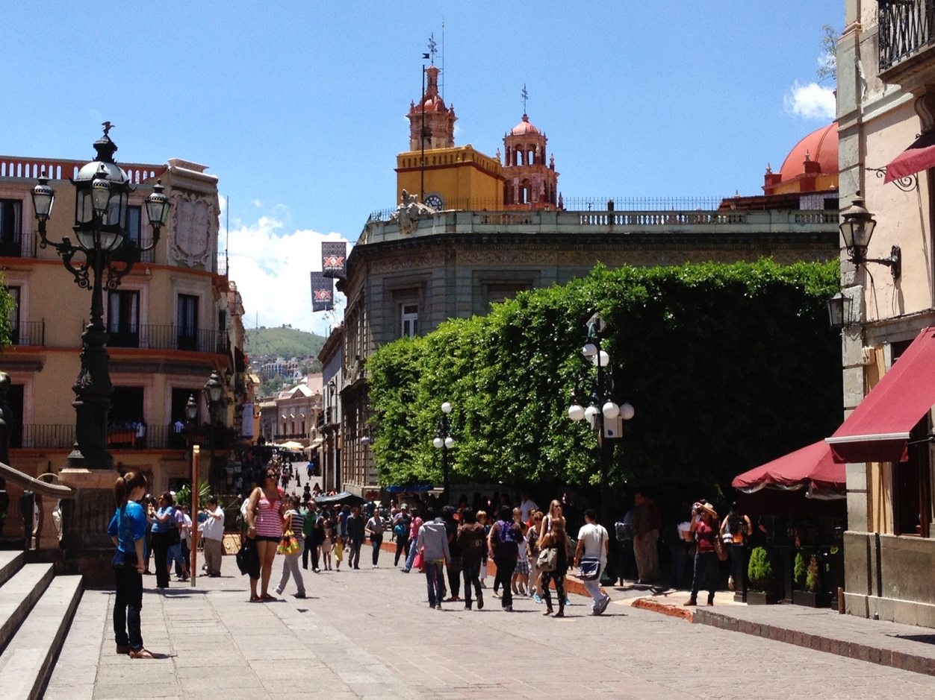

After all, it is a country with an extraordinary history, great diversity, wonderful beaches and colonial cities, and many very good people . . . and just like most of us U.S. citizens here, most Mexican citizens are proud of their country.

However, after a moment’s hesitation, they almost all acknowledged that Mexico, too, has huge problems. As one well-educated but enraged citizen said at that time, ‘I hate our president Pena Nieto even more than I hate your Trump!’ Indeed, much of Mexican history is very ugly and brutal, and still today, the violence and corruption are terrible. I just hope that Mexico’s new government can improve the situation . . . and that the U.S. government doesn’t continue its slide toward a similar level of corruption! Those of us who love Mexico and love the U.S. want both of them to be as great as possible.

But anxiety about the U.S. was, and continues to be, widespread. I have heard individuals from across Latin America and Europe, as well as Mexico, saying almost the same thing: ‘We grew up believing in the United States. Our parents taught us to admire Americans for helping everyone else after World War II and for being a role model in so many ways. And now, frighteningly, that’s been taken away. Yes, of course we always knew of America’s dark side: its treatment of Native Americans and Blacks and its imperialism abroad, but we also always saw America as the future of the world . . . and now that’s gone. No offense, but how could you vote for such a man as Trump?’

No offense, taken, I said, one particular time when I was addressed in that way . . . and that’s when I suddenly I heard the first notes of a very striking song. We were having dinner by the beautiful town square when we heard a slow, haunting guitar solo from a band across the way.

.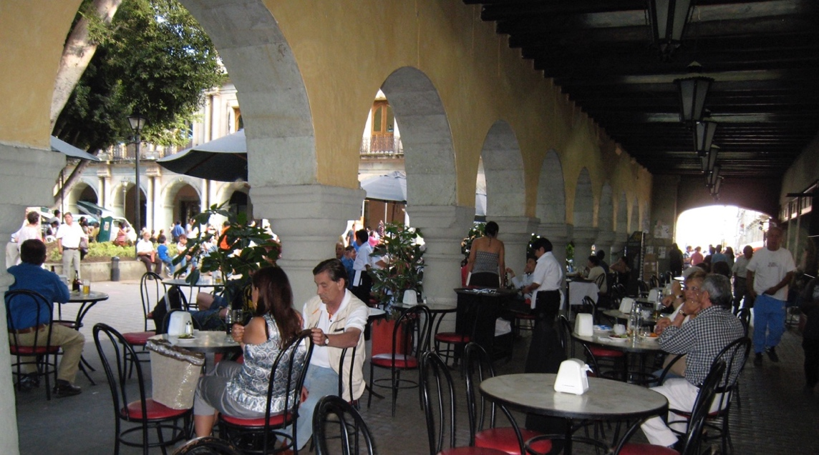

After a minute or two I began to realize that they were playing Pink Floyd’s song, The Wall. These very talented, young Mexican musicians had rewritten it to say, in effect, “up yours” to Trump -- the song was completely in Spanish except for the chorus, slightly altered, to be, “go ahead Trump, put another damned brick in the wall.” It was brilliant and powerful, and everyone, even at the upscale restaurant across the square, applauded enthusiastically.

In fact, Mexico’s come-uppance was immediately on display at that very plaza. There we met part of a 45-member delegation from the German state of Baden-Wurttemberg, corporate home of Porsche, Daimler, and Bosch. Trump had proudly touted his effort to keep American jobs from being exported to Mexico, so here were the Germans more than ready to capitalize on the situation. Mexico is already host to automobile and parts manufacturers from Japan, Germany, Canada, and the U.S. Now the Germans were ready to expand.

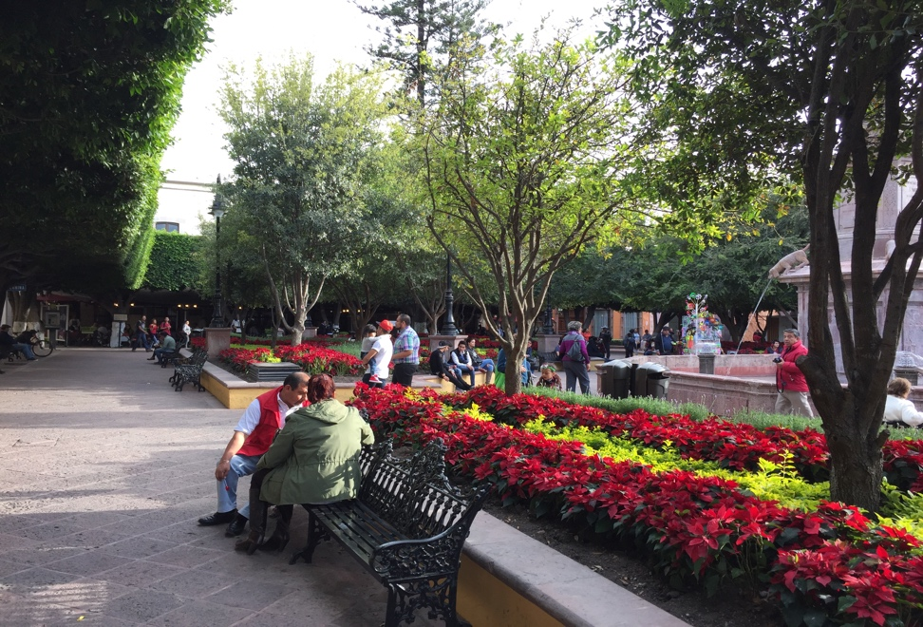

And they were doing so very strategically, with a delegation of politicians, corporate executives, academics, and some environmental experts. ‘If we are going to send our managers to live and work in Mexico, we want them and their families to have clean air and water, so one condition of our investing here is that the government allow us to help clean up their environment.’ I’d like to hear our President say something intelligent like that.

Unfortunately, what I do hear from Trump and his supporters seems to me to reek of self-interest and short-sightedness. When Trump thinks of the big picture, he doesn’t seem to have a vision of the future or the planet -- I guess it’s just a big picture of himself. How can we “win” if we don’t collaborate as a team, and how can we collaborate, if he keeps attacking everyone inside and outside of the country? The man and his policies infuriate me. OK, maybe I need to calm down a bit.

Trying to soothe me at that time, one kindly older gentleman from Mexico City said, ‘you know, we have learned the hard way that eternity must wait, and for now, you need to focus your attention on family and friends, and live as well as possible -- there’s really little you can do to change things politically.’

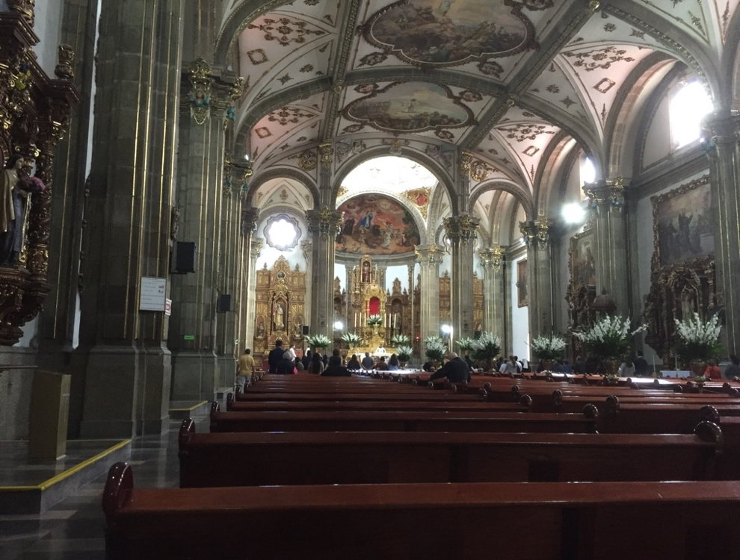

But that’s when I understood.

That, I responded, is precisely the difference between the U.S. and many other countries: yes, many Americans do think of eternity, but most of us believe we can change things in the here and now -- si, se puede, yes, we can! Perhaps we are deluded in this, but U.S. history is largely the history of people who did in fact change their lives by picking up and moving to America and starting anew. Our ancestors arrived in this country or went further west, saying, ‘Yes we can.’ Yes, we can change our circumstances, and yes we can change the world.

This belief has been shared by American liberals and conservatives alike. The main difference has been the degree to which we believe government can help or hinder this change, the degree to which we believe we are “self-made” or that it “takes a village.” We disagree about this, but we don’t seem to disagree that we can change things.

Some people in other parts of the world, and even some in the U.S. think that this belief is hopelessly naïve. And truth to tell, mobility in the U.S. is not as great as it used to be, and things often do seem beyond our control. Without a doubt, change is hard. What’s more, it is understandable that people in countries such Egypt, China, or Mexico -- with their very long, impressive histories -- would be fatalistic. They have witnessed great violence and upheaval many times, and when things have seemed stable for a while, it’s usually been because they have been ruled from the top.
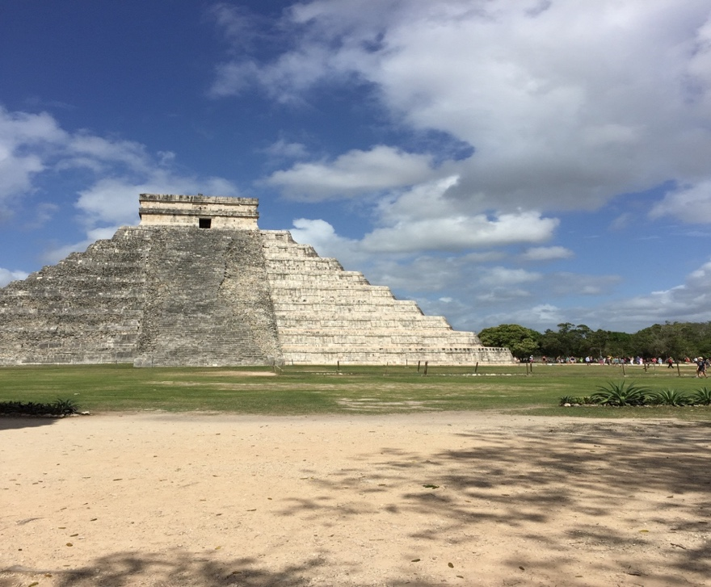

Old as these countries are, they have much less experience creating their destinies than we Americans do. We insist on the rule of law, and we are focused on the future. But that is also why so many people around the world have admired the United States -- millions of people from these other countries want to believe in change, too. And in many cases they are today acting on that belief.

In fact, the next day, at the very same square we had enjoyed so much, there was a day-long political demonstration of several hundred people calling for greater economic equality (after all, for many people in the area, one dinner at the elegant restaurant there might cost as much as their weekly wage.) There clearly needs to be change.

But let’s not forget that this is Mexico, and when evening darkness fell upon the plaza, the music began again -- orchestral here, salsa over there . . . and even though we did not know the steps, we eagerly joined in the dancing.
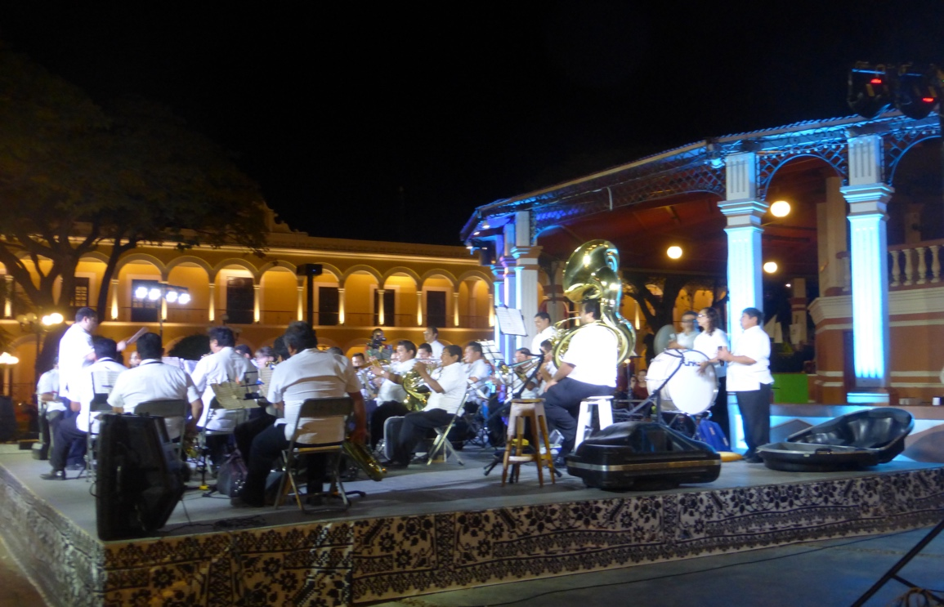

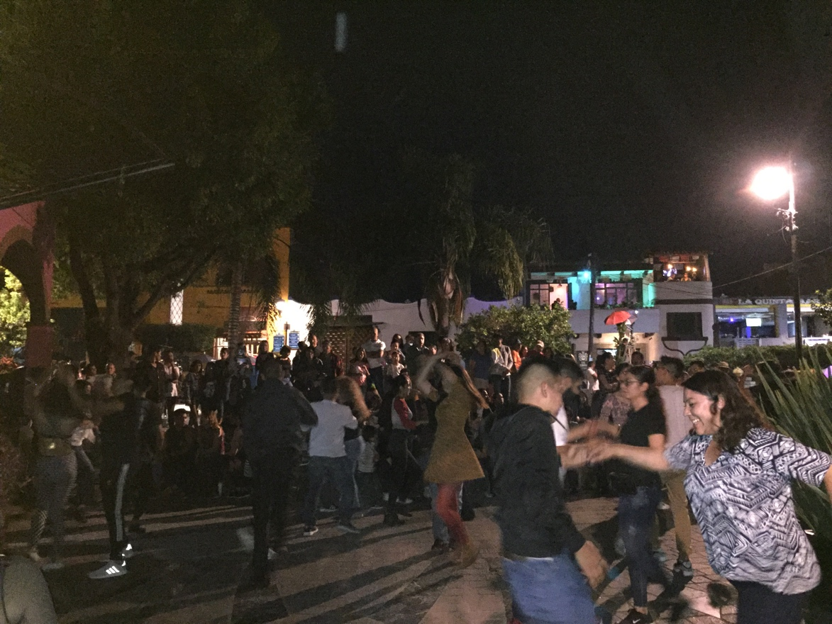

So, I’m glad for the reminders that my friends south of the border have provided me. I may be retirement age, but I care about the future and will work for change. I will embrace change. I do not look to the past to “make America great again.” I look ahead -- to make America greater, and to make the world greater. And I do not look just to America -- I look for help and progress all around the world.

“My Country” is the United States of America. But it is also Mexico, to some degree, even though I am not of Mexican descent. My country is also Canada, Germany, Italy, Spain, France, Israel, Japan, Chile, Morocco, and many of the other countries of the world I know from study or work or travel, or from friends who know these places well. I love my country and I am critical of it; I am a globalist but see globalism’s flaws. I love my neighborhood, but see it needs improvement. Each of us has a lot of work to do, even at home.

Of course, I don’t expect miracles, but I do expect to make a difference, however small. Like my ancestors, and like everyone who has come to America, I believe in the future as something for us to build together.

And so, I will take one step forward to demonstrate with you and one step forward to dance with you. This is the least we can try to do for our neighbors around the world. They are watching our moves -- so let’s move forward!

THREE: MY COUNTRY, STILL

I felt peculiarly, progressively, patriotic, there in Washington, DC, last Autumn. The grand buildings, the beautiful parks, the powerful monuments. I was surprised, too, how proud I felt, when visitors we encountered from Canada and Brazil marveled at how magnificent and impressive our nation’s capital is. I was proud, too, that I could walk right in to our Congressional offices and talk with the staffers and, if we’d stayed a day longer, then go sit in on Congressional hearings. 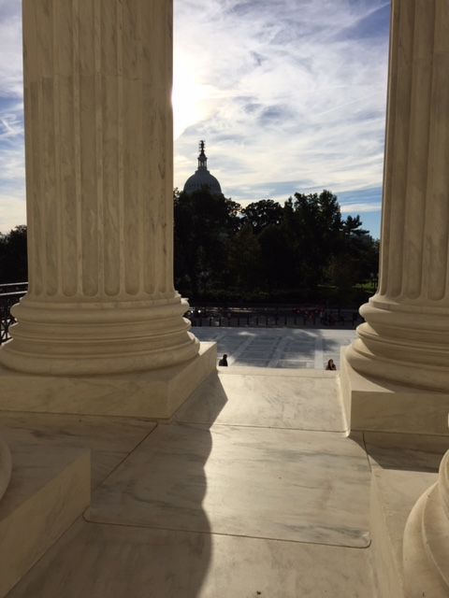
I was proud to review our history at the Museum of American History, awed by the words of Lincoln, F.D.R., and M.L.K., Jr., chiseled on their monuments, and deeply moved by the Vietnam and Korean war memorials.
I felt love for this country that my ancestors had fled to 130 years ago and imagined how choked up they must have been, sighting the Statue of Liberty, as they arrived in our country. They were very thankful for the United States.
And yet, they criticized some things they witnessed and hoped the United States would become a greater country. And they taught us that patriotism must not be blind.
So, we stood in front the U.S. Supreme Court and protested.
So, we stood in front of the White House and protested.

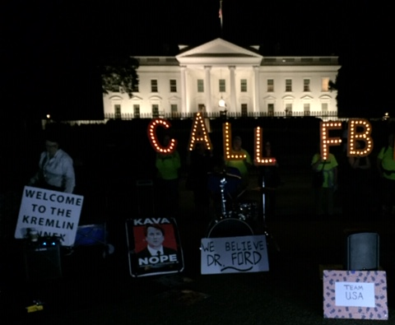

We attended the Hispanic American parade on Constitution Avenue and saw groups from dozens of Latin American countries celebrating their cultures and their U.S. citizenship.
We had brunch with our son and his girlfriend and her parents, who had immigrated here from Cuba and from South Africa.
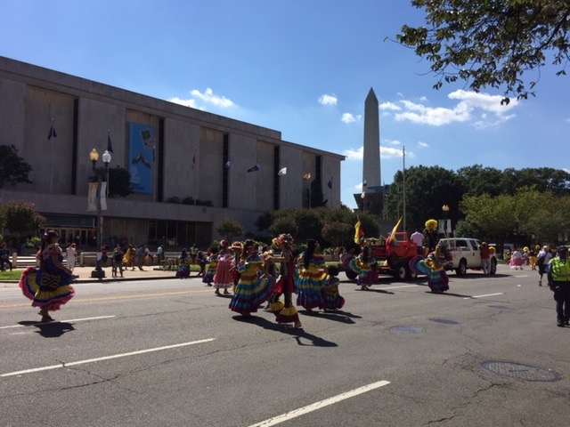And we agreed that genuine patriotism can never be pride in the past – alone, or primarily – but must be a real determination to make things better for the future. This means recognizing where we’ve failed, where problems and suffering continue to exist and might be growing. This means facing all that’s wrong with America (and with ourselves) and pushing it (and ourselves) to grow. If you visit the monuments across Washington DC, you cannot help but see this. Jefferson, Lincoln, FDR, and the others all recognized our shortcomings, and all spoke of going forward.
The ideals on their monuments do not address so much our past accomplishments, but our goals for the future. The words are carved in stone, but they are not meant to be static. They are our tasks for the future. They are our aspirations.
So, we should be proud, and we should be thankful, but we should not be complacent.
And we should not be complicit with evil. We should not give in to fear.
Most of us, except those who unfortunately had no say in the matter, came here for a brighter future. Now, we must work for all of us to have as bright a future as possible. We cannot accept a backwards-looking patriotism.
Visiting Washington, DC helps me understand that most Americans could view themselves as Progressive Patriots. Progressive Patriotism is thankful, but critical; inclusive, not nativist; it is rooted in our U.S. history but addresses our global future. It is hopeful.

The photographs shown here of Mexico, from Oaxaca, Guanajuato, Queretaro, Campeche, Yelapa, Guadalajara, and Mexico City, taken over the past decade, all represent the appealing side of Mexico -- it is sadly, quite easy to show photographs of Mexican slums and crime victims as well. Images of the US are from Walnut Creek, CA and Washington DC – one could easily show equally depressing images of our country.

Robert Paul Weiner
116 Arlene Dr., Walnut Creek, CA 94595; Tel: 510-219-0606 rob@creativityandbeyond.com

